*Case Study 5.3****:* Compression low**V.1.1



Introduction

Method

Special measures implemented

Detected compression (case example)

Brief excursion regarding the two G6 sensors in use

Loop response to the compression low

Logfile analysis

Discussion of results

Addendum

Introduction: Why compression lows *could be* problematic

Many loopers experience sudden **compression** lows at night, when lying on the CGM sensor.

This is followed by a jump in sensor bg value when the body is turning and pressure is relieved.

The loop could misinterpret this as a sharply rising bg that might require a SMB.

In section 5 of the FCL e-book (https://github.com/bernie4375/FCL-potential-autoISF) principal approaches are discussed to safeguard against the autoISF loop over-reacting after a glucose jump that might be an artefact.

Method

FCL (no carb inputs, no user boli) with dev variant of AAPS 3.2.0.4 w/autoISF 3.0.1:

Lyumjev 100 (DIA 7h) in Combo pump w/ 10mm Teflon cannula (0-48h)

2 x G6 overlapping (see case study 1.5);; xDrip, no smoothing in AAPS)

TDD ~ 35 U; profile basal ~ 14 U (0.41…0.75 U/h); profile_ISF 36…44 mg/dl/U; iobTH% = 0.6

**\*) Caution: Do not copy settings** from others,

not even for starting your tuning.

Why, see FCL e-book section 4.1.

Key autoISF settings**\*)**:

SMB size limited at ~ 3.5 U (=2.9 x 120 minutes basal)

autoISFmax = 2.9; SMB delivery ratio = 0.75 fixed

bgAccel_ISF_weight = 0.22; break_weight 0.12; lower:ISF-range_weight 0.7; higher_ISF-range_weight 0.1; pp_ISF_weight = 0.03; dura_ISF_weight 0.8

Special measures implemented to prevent problems from compression lows

* **Odd nighttime profile target to exclude SMBs**

Following suggestions as in FCL e-book section 5.1.2, I set for my sleep time an **odd profile target** at which no SMBs can be given by the loop.

However, this can conflict with nights where, after a fatty late dinner, I might need a SMB or two to get bg down that seems “stuck high” =>

* **Automation for still allowing SMBs when needed**

Automations as shown in FCL e-book, section 5.1.2. are running for when might need extra insulin in night times. However, these are running only for a very brief period of a few minutes.

This brief, focused duration would not “ruin” the automatic vigilance against compression lows at any point during my bedtime.

What could ruin it still is, if the odd nighttime profile target could be auto-terminated! =>

* **Checking *all* (!) Automations**: **None should end the odd profile target at night**

In fact I do have an Automation (shown below) that sets a TT of 74 mg/dl to magnify SMBs whenever bg jumps up strongly. This Automation was meant to “replace” EatingSoonTT (see FCL e-book, section 2.5). Only by restricting such Automations to daytime, the nighttime odd profile target will sure remain in place and prevent SMB (see the following case report).

As the following example shows, bg deltas after a compression low can be quite high and in fact would trigger that “EatingSoonTT” Automation …

Detected compression low (case example)

07:27 h: xDrip widgets on my main phone screen

Left side is the G6 in use since over 3 days. The red dot indicates my loop had to deal with a compression low, because we do not see such bump on the G6 sensor on the right arm., rthat still runs quite well on it’s 15th day of use with Anubis transmitter, and therefore luckily can serve as “quality judge” here:

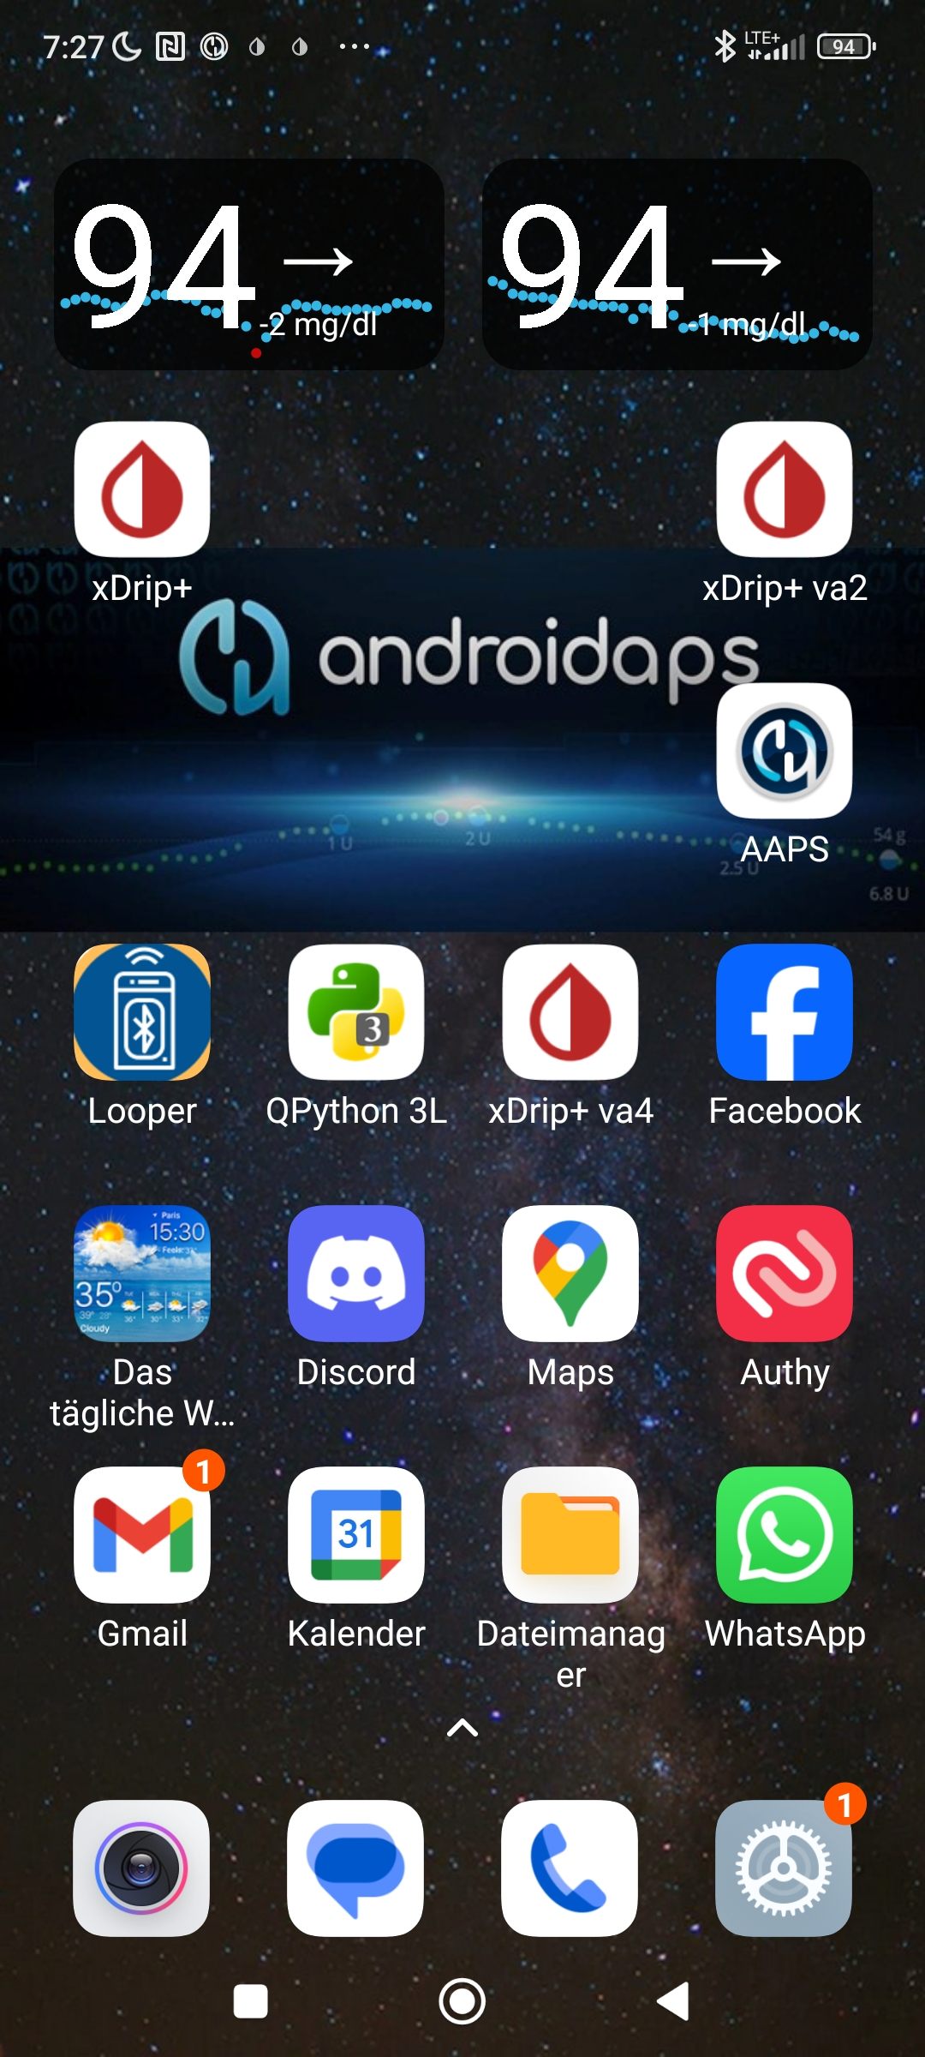

3 d 6 h 14 d 6 h after sensor start

Directly in xDrip resp. xDripVariant2 app, we can see better what exactly happened:

06:00 h: Compression low (left side), followed by sharp glucose ris

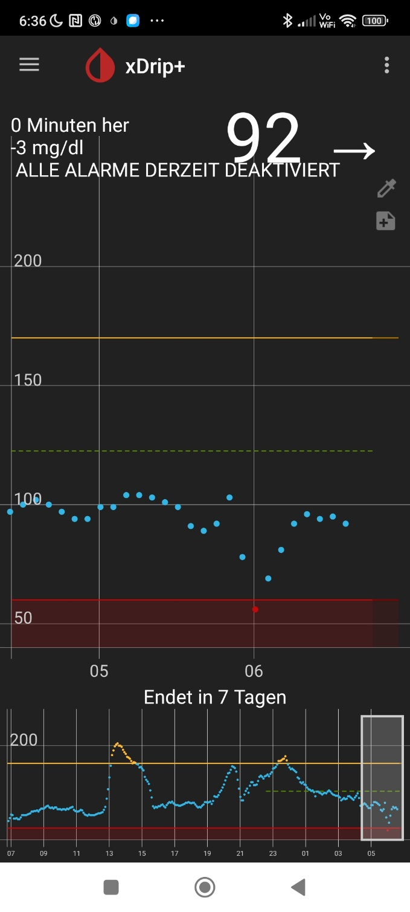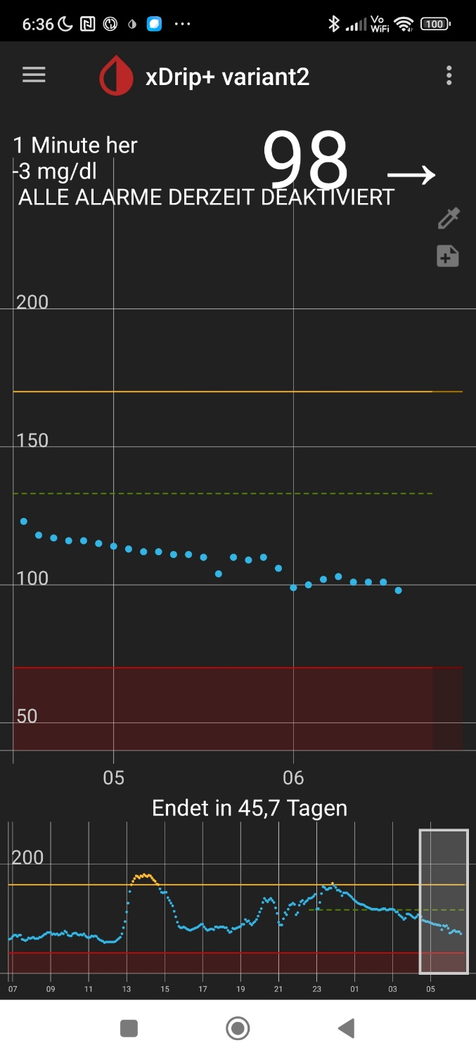

The sensor on the left side is 3 d 6 h old, so that one was connected to AAPS in that night because we should assume it works actually *better* than the 14 d 6 h old sensor operating with Anubis on the right..

Note that the extra sensor on my right arm does not interfere (“help”) in any way in the loop’s workings. It only happened to be there in parallel, and incidentally can provide proof that the values from the left arm (that my loop was operating with) were actually having a problem.

A nightly hypoglycemia could easy have resulted if the implemented automated safeguarding measures were not sufficient.

Before we analyze this case in more detail to see how the taken measures exactly worked out, some more details on the two G6 sensors

Brief excursion regarding the two G6 sensors in use

Regarding permanent reliable CGM values via 2 x G6, see also extra Case study 1.5

This compression case is especially nice to report as it is from a night in which **both** G6 sensors were already (left side) or still (right side) in good shape, as shown with the pictures on the two preceding pages.

However, this was not at all the case in the first 24 hours:

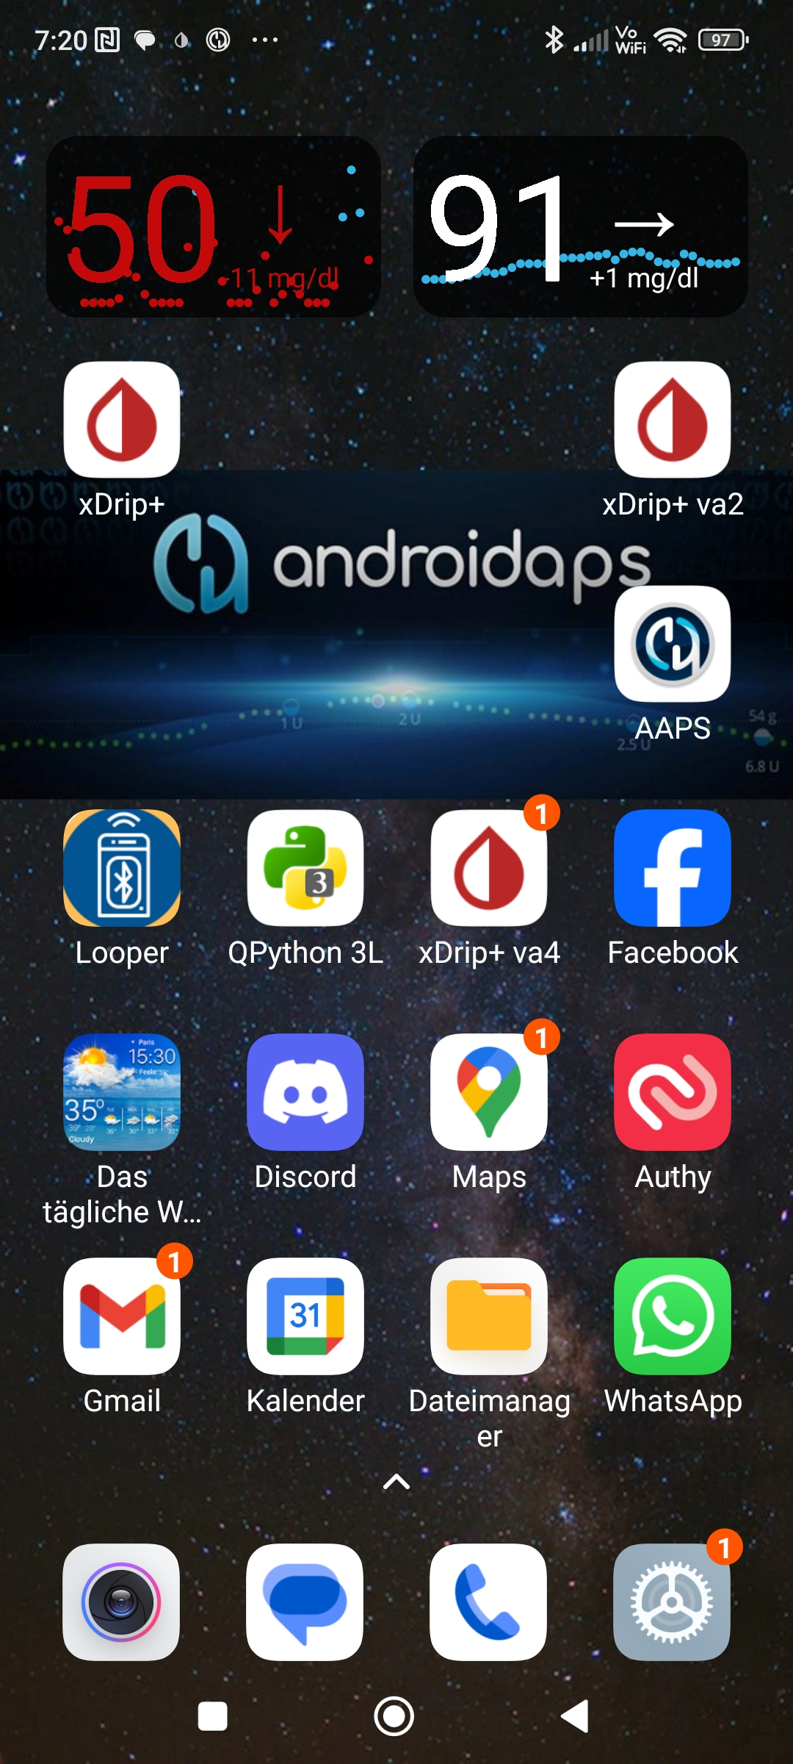

This is a screenshot from only **six hours** after

starting (after midnight, before going to sleep)

the new g6 (left side)

It gave very erratic too low values all night:

6 h 11 d 6 h after sensor start !

The 11 d older G6 on the right side was still

feeding the AAPS loop which nicely regulated

the bg in a pretty flat line around 90 mg/dl all night:

But *without doing any calibration,*  eventually



data got in fairly well line with reality,

and also with the other one:

This is a screenshot from ~ 23 hours after the

new g6 (left side) had been started, and took over

feeding the AAPS loop from the right side G&

23 h 11 d 23 h after sensor start !

which then had been already 11 d 23 h running

(with Anubios transmitter),

It was in the following night, that the compression low happened on the left arm (see two preceding pages, and the discussion that foillows on the next pages).

Loop response to a compression low, with implemented pre-cautions (example,)

Here the AAPS screen from the night withg the compression low,

and the log of recent bg values:

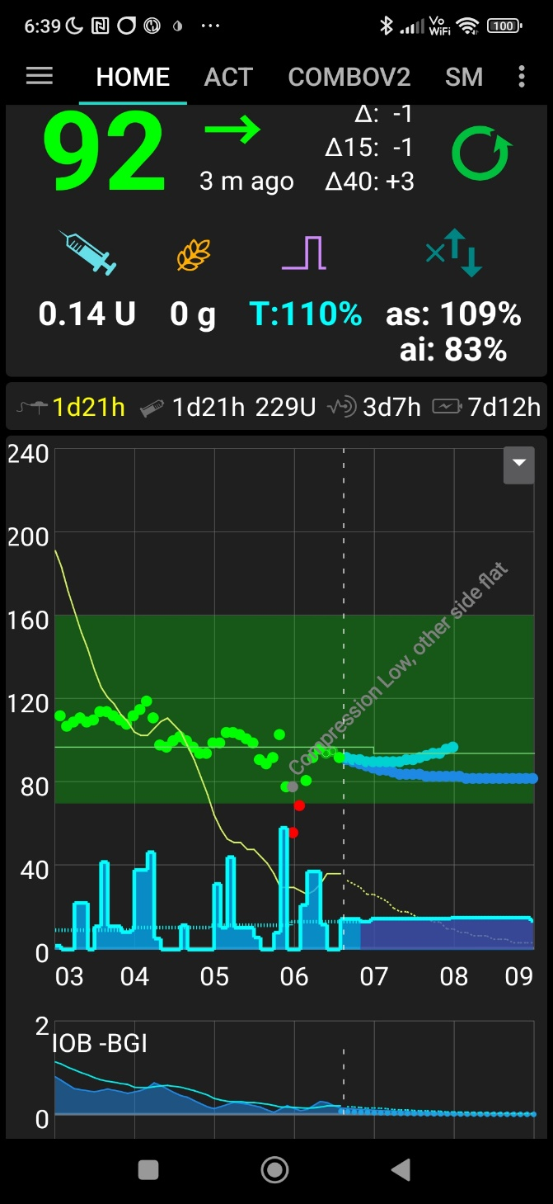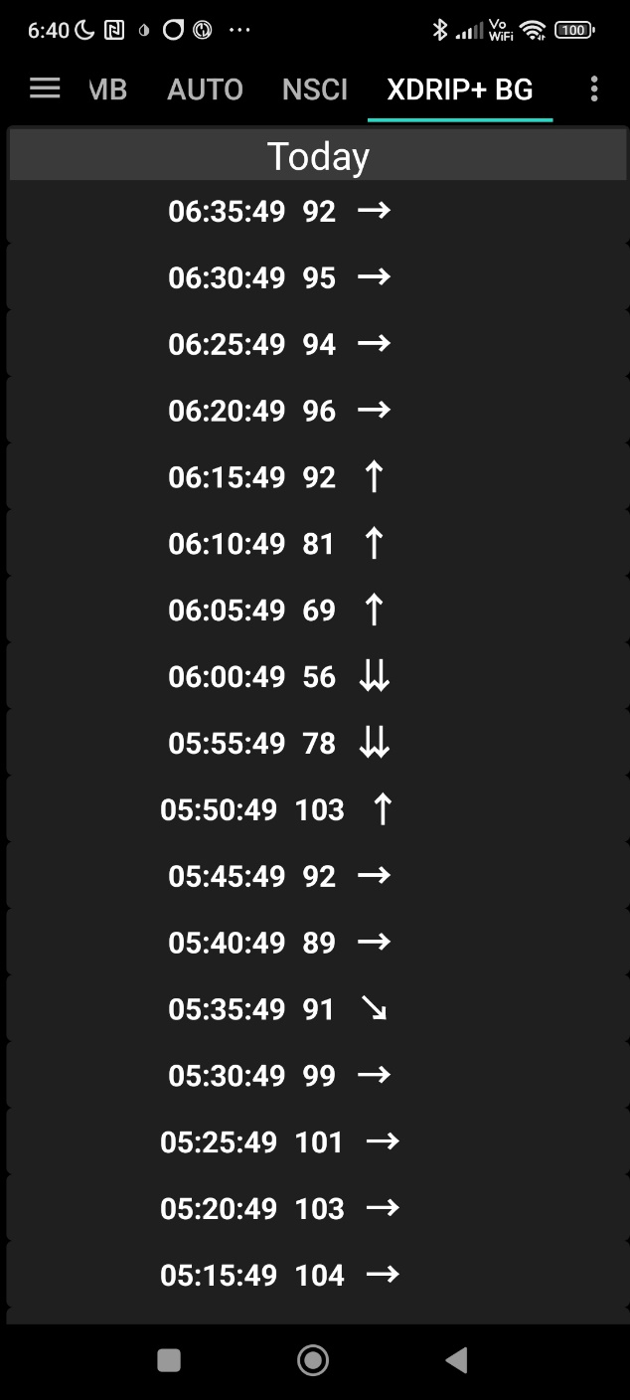

minus  **47**

06:06 **+ 13**

06:16 **+ 11**

06:16 **+ 11**

06:11 **+ 12**

06:06 **+ 13**

05:51 **+ 11**

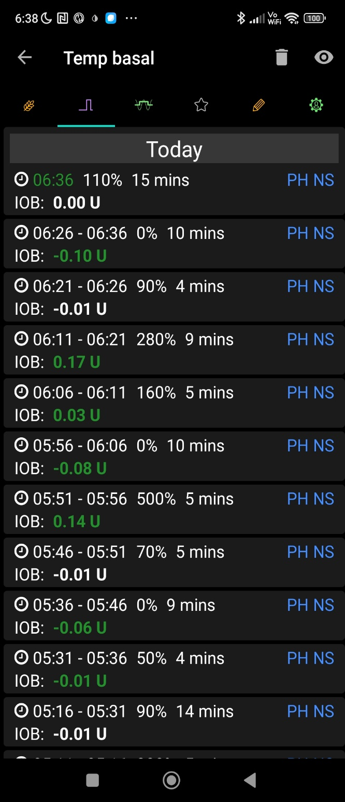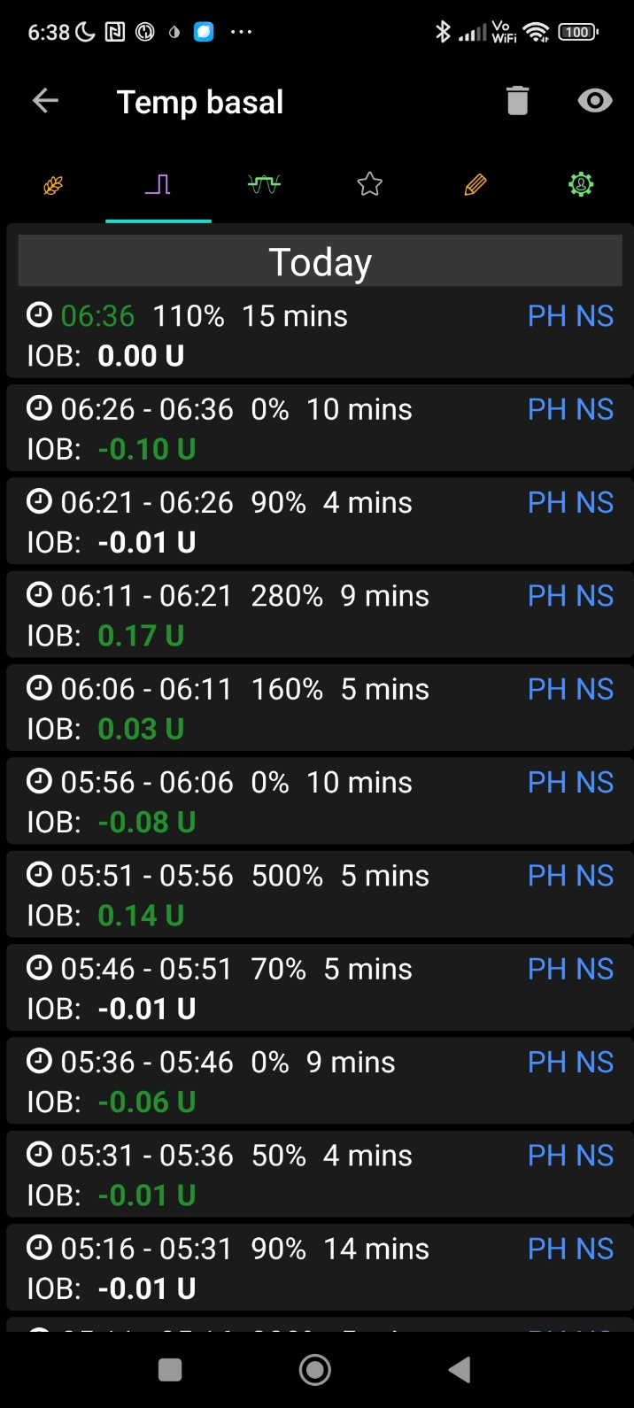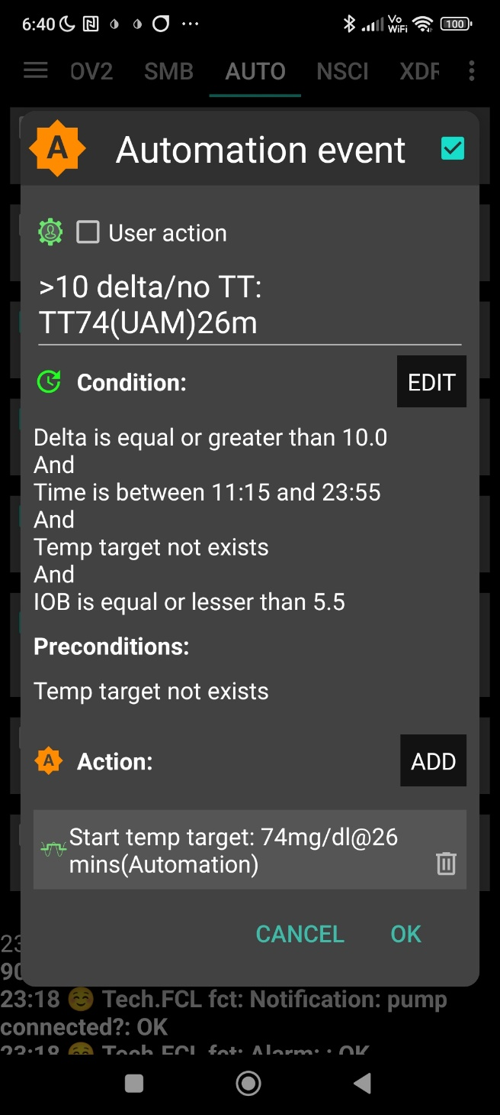

05.50 – 6:00 the compression low went from 103 all the way down to 56 ( minus 47 ! )

The **bg deltas** up by **>** **+10** are marked red (adding up to + 47 !) **trigger** …

as no SMBs can be given in the night (due to odd profile target after 02:30 am) …

**.. 500%, 160%, 280% and 90% TBR** (issued for ~ 5 minutes each) , and,

at 0.6 U/h = 0.05 U/5min basal **amounting**

|  |  |  |  |  |
| --- | --- | --- | --- | --- |
| TBR | U | U above basal | min | U * min/5  cumulated |
| 500% | 0.25 | 0.20 | 5 |  |
| 160% | 0.08 | 0.03 | 5 | 0.23 |
| 280% | 0.14 | 0.09 | 9 | 0,38 |
| 90% | 0.045 | -0.005 | 4 | 0.38 |

..**to, *in total*  0.38 U** in our case here, an error in hindsight, that the loop has the capacity to balance out, just by reducing basal (0.6 U/h in profile).

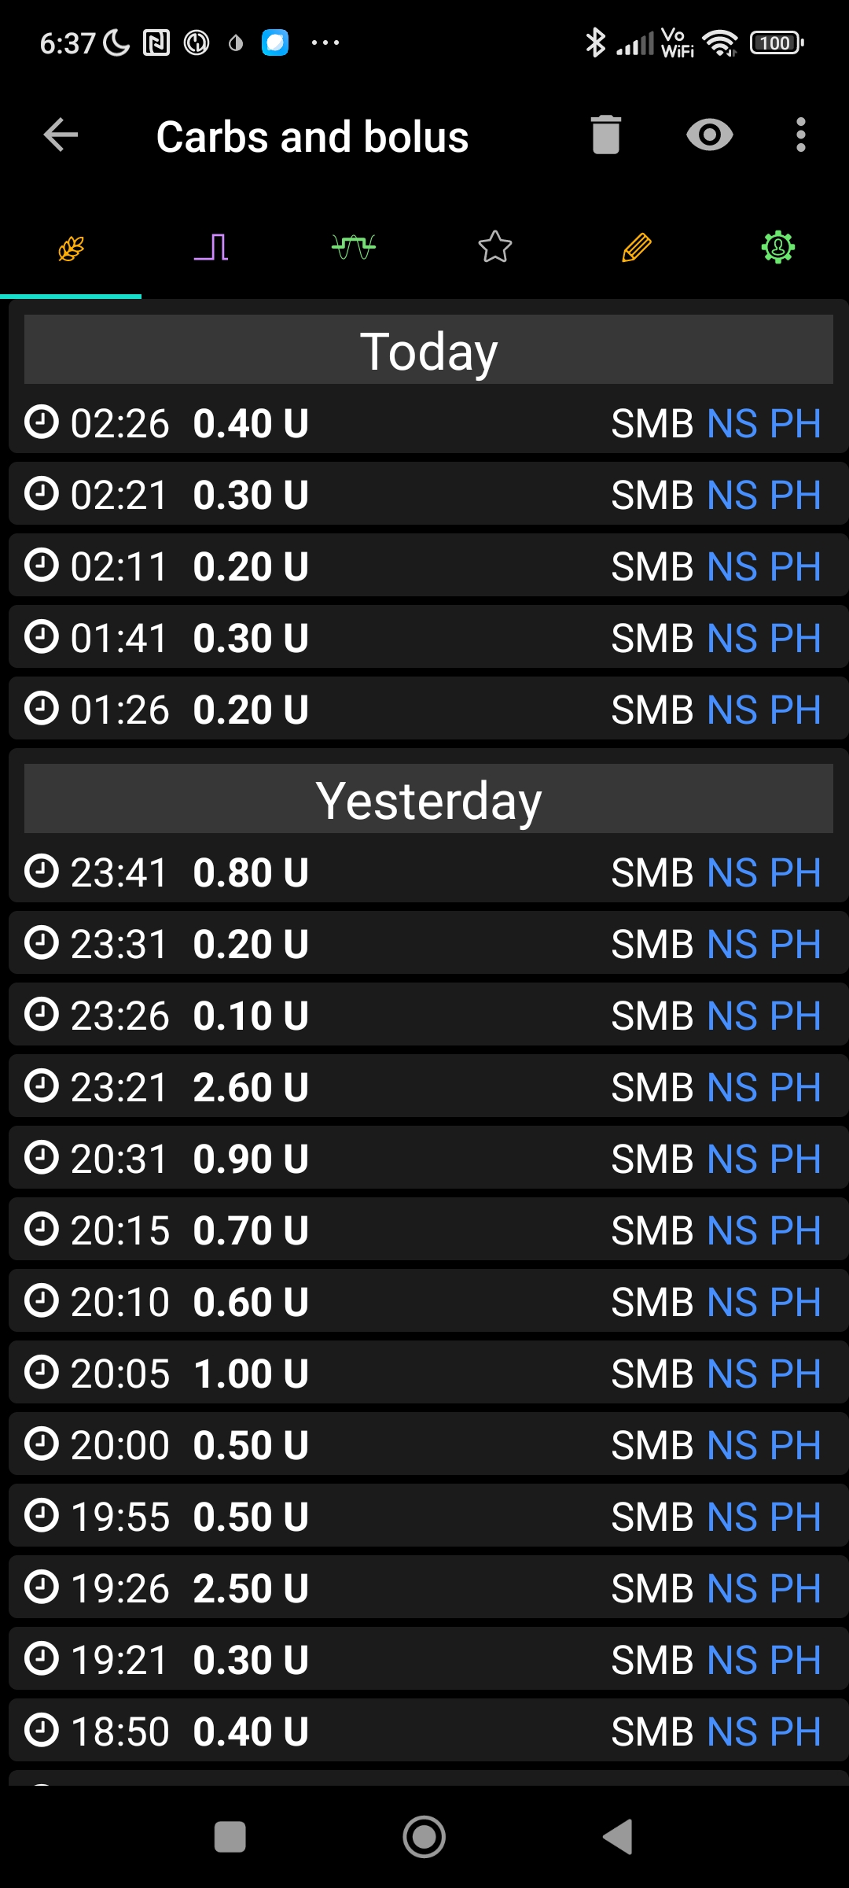

05:51 **+ 11**

06:06 **+ 13**

06:06 **+ 13**

05:51 **+ 11**

So, (previous page), the four bg jumps did not lead to strong iob growth.

The autoISF triggered strengthened ISFs were leading only to three, each 5 – 9 minutes long, segments with strongly elevated %TBR that together amounted to 0.38 U see calculation on the previous page), which is well below a typically SMB that we otherwise would have seen.

The **Automation** shown on the left…

- which is helpful to boost SMBs after a meal start (see FCL e-book section )

…would, however, set a low and even TT at bg deltas above 10, and would allow SMBs in all 4 instances!

This Automation was restriced though to potential times of major meals (11:15 - 23:55 h), so, luckily, it did **not** become activated.

My autoISF still did strengthen ISF significantly at the detected acceleration and rise (see section with logfile analysis, below), however via TBR the effect on iob was very limited (see table bottom left on previous page).

Logfile analysis using the emulator

For a more detailed analysis how the autoISF loop dealt with the erratic CGM data that came with the compression low between 05:45 and 06:15 h, we now turn to an Emulator-based logfile analysis.

Note: The AAPS logfiles are generally using universal time (Greenwich standard time) which in summer is minus 02:00 hours to central European summer time as on my phone and AAPS.

The table on the following page is an extraction of key info from the “noChange-csv”

as obtained following FCL e-book section 10.2.3 and 10.2.4.

The yellow fields in column E mark instances of jumps that should be connected with a detected acceleration (then, or in the preceding 5-10 minutes), with poitential bgAccel_ISF impact.

Indeed this is what we see in lines 26 and 42, but not in lines 29-31 where the recovery from the low in line 28 took place.

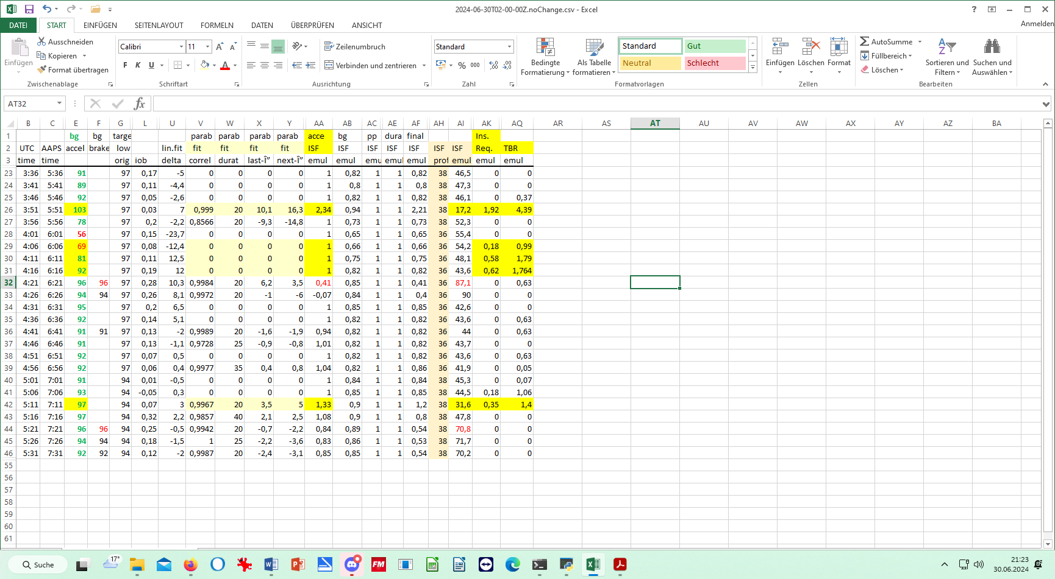

It looks like the “fit” is a problem in these instances.

Does that mean that autoISF detected that something is wrong, is untypical, with this bg curve shape from a compression?

Searching in another results file, specifically for these time slots of lines 29-31, we find the following:

Line 26: created at= 2024-06-30T03:51:07.214Z

---------- Script Debug --------------------

Activity monitor disabled: Phone seems not to be carried for the last 15m

Autosens ratio: 1; Basal unchanged: 0.55; ISF unchanged: 38; CR: 6.2

----------------------------------

start autoISF 3.0.1

----------------------------------

User setting iobTH=60% not modulated

SMB disabled; current target 97 is odd number; Loop allows minimal power

acce_ISF adaptation is 2.34

bg_ISF adaptation is 0.94

bg_ISF adaptation lifted to 2.21 as bg accelerates already

final ISF factor is 2.21

----------------------------------

end autoISF

----------------------------------

currenttemp: 0.39 lastTempAge: 0 m tempModulus: 25 m

profile.sens: 38 sens: 17.2 CSF: 2.77

Limiting carb impact from 7.5 to 6.9 mg/dL/5m ( 30 g/h )

Carb Impact: 6.9 mg/dL per 5m; CI Duration: 0 hours; remaining CI (~2h peak): 0 mg/dL per 5m

UAM Impact: 7.5 mg/dL per 5m; UAM Duration: 0.5 hours

minPredBG: 130 minIOBPredBG: 140 minZTGuardBG: 103

minUAMPredBG: 120 avgPredBG: 130 COB: 0 / 0

BG projected to remain above 97 for 240 minutes

naive_eventualBG: 103 bgUndershoot: -35 zeroTempDuration: 240 zeroTempEffect: 38 carbsReq: -26

---------- Reason --------------------------

COB: 0, Dev: 45, BGI: 0, ISF: 17, CR: 6.2, Target: 97, minPredBG 130, minGuardBG 109, IOBpredBG 140, UAMpredBG 120; Eventual BG 148 >= 97, temp 0.39 < 4.39U/hr.

Line 29 created at= 2024-06-30T04:06:09.680Z

---------- Script Debug --------------------

Activity monitor disabled: Phone seems not to be carried for the last 15m

Autosens ratio: 1; Basal unchanged: 0.63; ISF unchanged: 36; CR: 6

----------------------------------

start autoISF 3.0.1

----------------------------------

User setting iobTH=60% not modulated

SMB disabled; current target 97 is odd number; Loop allows minimal power

acce_ISF adaptation by-passed as correlation 0 is too low

bg_ISF adaptation is 0.66

final ISF factor is 0.66

----------------------------------

end autoISF

----------------------------------

currenttemp: 0 lastTempAge: 0 m tempModulus: 20 m

profile.sens: 36 sens: 54.2 CSF: 9.03

Carb Impact: 13.5 mg/dL per 5m; CI Duration: 0 hours; remaining CI (~2h peak): 0 mg/dL per 5m

UAM Impact: 13.5 mg/dL per 5m; UAM Duration: 0.2 hours

minPredBG: 107 minIOBPredBG: 139 minZTGuardBG: 67

minUAMPredBG: 76 avgPredBG: 107 COB: 0 / 0

BG projected to remain above 97 for 0 minutes

BG projected to remain above 68 for 240 minutes

naive_eventualBG: 64 bgUndershoot: 4 zeroTempDuration: 240 zeroTempEffect: 137 carbsReq: -15

---------- Reason --------------------------

COB: 0, Dev: 81, BGI: 0, ISF: 54, CR: 6, Target: 97, minPredBG 107, minGuardBG 76, IOBpredBG 139, UAMpredBG 76; Eventual BG 145 >= 97, temp 0.00 < 0.99U/hr.

Line 30 created at= 2024-06-30T04:11:14.448Z

---------- Script Debug --------------------

Activity monitor disabled: Phone seems not to be carried for the last 15m

Autosens ratio: 1;; Basal unchanged: 0.63;; ISF unchanged: 36; CR: 6

----------------------------------

start autoISF 3.0.1

----------------------------------

User setting iobTH=60% not modulated

SMB disabled; current target 97 is odd number; Loop allows minimal power

acce_ISF adaptation by-passed as correlation 0 is too low

bg_ISF adaptation is 0.75

final ISF factor is 0.75

----------------------------------

end autoISF

----------------------------------

currenttemp: 1.01 lastTempAge: 0 m tempModulus: 25 m

profile.sens: 36 sens: 48.1 CSF: 8.02

Carb Impact: 12.4 mg/dL per 5m; CI Duration: 0 hours; remaining CI (~2h peak): 0 mg/dL per 5m

UAM Impact: 12.4 mg/dL per 5m; UAM Duration: 0.5 hours

minPredBG: 125 minIOBPredBG: 144 minZTGuardBG: 80

minUAMPredBG: 105 avgPredBG: 125 COB: 0 / 0

BG projected to remain above 97 for 0 minutes

BG projected to remain above 68 for 240 minutes

naive_eventualBG: 76 bgUndershoot: -8 zeroTempDuration: 240 zeroTempEffect: 121 carbsReq: -16

---------- Reason --------------------------

COB: 0, Dev: 74, BGI: 0, ISF: 48, CR: 6, Target: 97, minPredBG 125, minGuardBG 91, IOBpredBG 144, UAMpredBG 105; Eventual BG 150 >= 97, temp 1.01 < 1.79U/hr.

Line 31 created at= 2024-06-30T04:16:13.829Z

---------- Script Debug --------------------

Activity monitor disabled: Phone seems not to be carried for the last 15m

Autosens ratio: 1; Basal unchanged: 0.63; ISF unchanged: 36; CR: 6

----------------------------------

start autoISF 3.0.1

----------------------------------

User setting iobTH=60% not modulated

SMB disabled; current target 97 is odd number Loop allows minimal power

acce_ISF adaptation by-passed as correlation 0 is too low

bg_ISF adaptation is 0.82

final ISF factor is 0.82

----------------------------------

end autoISF

----------------------------------

currenttemp: 1.76 lastTempAge: 0 m tempModulus: 25 m

profile.sens: 36 sens: 43.6 CSF: 7.27

Carb Impact: 11.3 mg/dL per 5m; CI Duration: 0 hours; remaining CI (~2h peak): 0 mg/dL per 5m

UAM Impact: 11.3 mg/dL per 5m; UAM Duration: 0.4 hours

minPredBG: 124 minIOBPredBG: 146 minZTGuardBG: 90

minUAMPredBG: 102 avgPredBG: 124 COB: 0 / 0

BG projected to remain above 97 for 0 minutes

BG projected to remain above 68 for 240 minutes

naive_eventualBG: 84 bgUndershoot: -16 zeroTempDuration: 240 zeroTempEffect: 110 carbsReq: -17

---------- Reason --------------------------

COB: 0, Dev: 68, BGI: 0, ISF: 44, CR: 6, Target: 97, minPredBG 124, minGuardBG 100, IOBpredBG 146, UAMpredBG 102; Eventual BG 152 >= 97, temp 1.76 < 1.87U/hr. 25m left and 1.764 ~ req 1.87U/hr: no temp required

Indeed, bgAccel_ISF was not applied in the time around the big deltas that resulted when the compression low resolved: The parabola fit analysis revealed zero correlation in these cases.

Discussion of results

**Pre-cautions** implemented against getting SMBs after a compression low consisted of

* setting a nighttime odd profile glucose target
* defining Automations for still allowing SMBs *when needed*
* Checking *all* (!) Automations: None should end the odd profile target at night

and were **sufficient to safeguard** against problems from compression.

The emulator-based logfile analysis revealed more good news; There is ***complementary, intelligent analysis and plausibility checks*** also ***built into the autoISF acceleration detection*** which, in the presented compression problems case, would largely have prevented the dreaded SMBs, *even without* employing any of the implemented pre-cautions.

Addendum to be used evtentually in a later update

The following is a chart produced by the emulator (refer to e-book section 10.2.4.4)-

Z + 2 hours = AAPS time (central EU summer); June 30, 2024 early morning

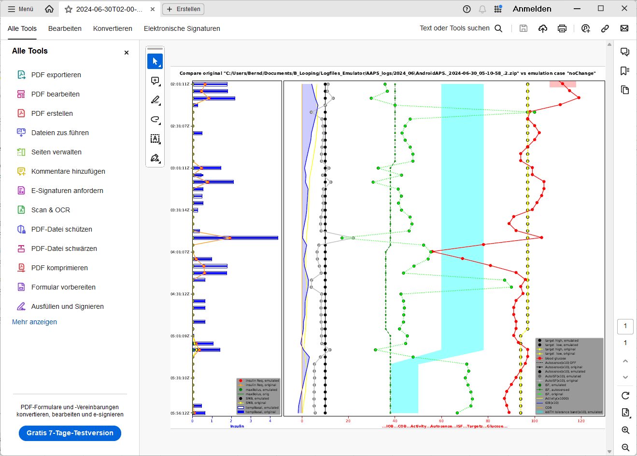

What insights can be draw from it ?

Is it generally more useful in context with a “What-if” analysis?